Name……………………………………………………….… Adm No………………. Class………

Candidate’s Signature…………………….…………….….…...Date……………………………….

**FORM 4**

**TIME: HRS**

**JULY 2024**

**MUSIC PP3**



(SCHOOL OF CHOICE)

**BRISINGA EXAMS – 2024 SERIES**

***Kenya Certificate of Secondary Education***



**Instructions to Candidates**

* Write your name, admission number in the spaces
* provided.
* Answer all questions in this paper in the spaces provided
* Candidates should check the question paper to ensure that all the pages are printed as indicated and
* no questions are missing.

**FOR EXAMINERS USE ONLY**

|  |  |  |  |
| --- | --- | --- | --- |
| **SECTION** | **QUESTION** | **MAXIMUM SCORE** | **CANDIDATE’S SCORE** |
| A | 1 | 15 |  |
| 2 | 15 |  |
| B | 3 | 14 |  |
| 5 | 10 |  |
| 6 | 10 |  |
| 7 | 6 |  |
| C | 8 | 16 |  |
|  |  |  |
| **TOTAL** |  | 100 |  |

1. (a)Continue the following opening to make a 16 bar melody for voice modulate to the subdominant before returning to the tonic. Introduce sequence and a triplet.

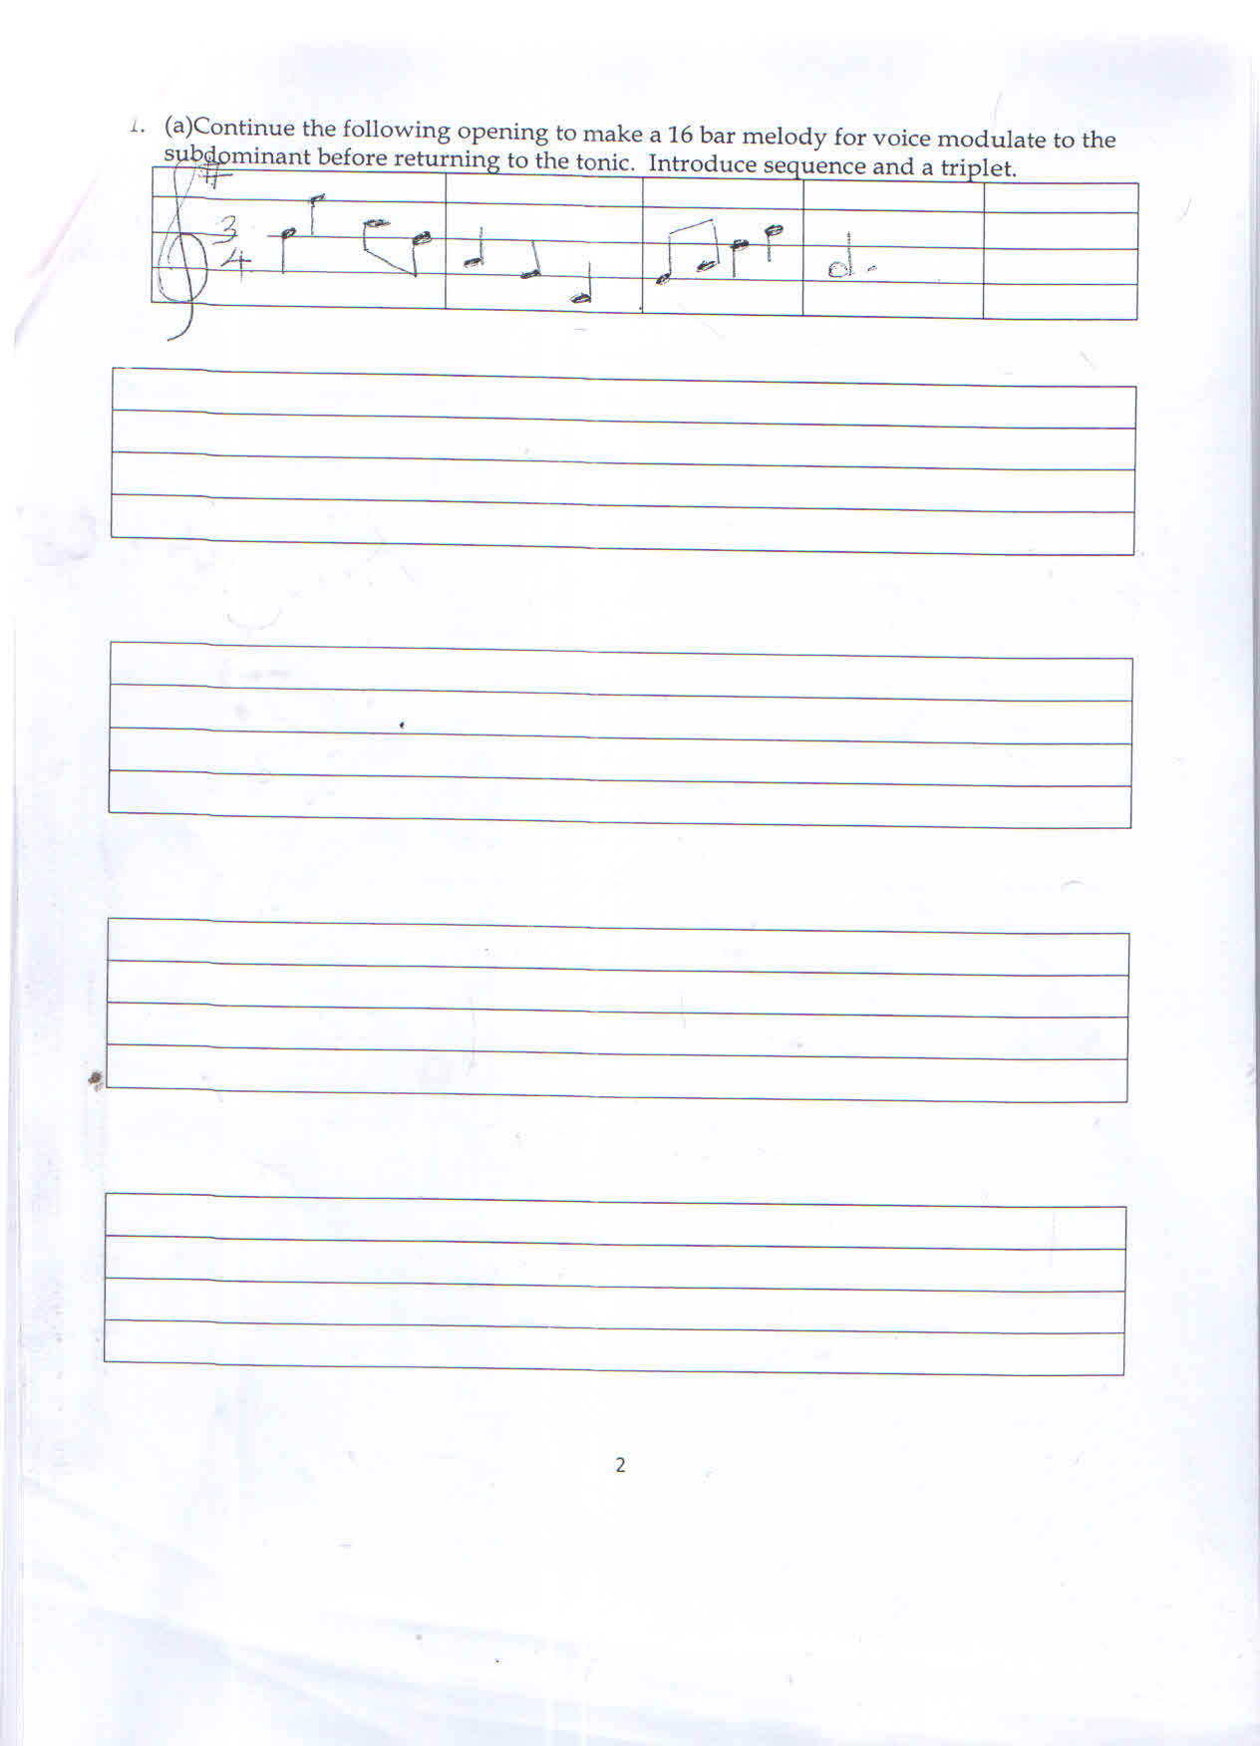

|  |
| --- |
|  |
|  |
|  |
|  |

|  |
| --- |
|  |
|  |
|  |
|  |

|  |
| --- |
|  |
|  |
|  |
|  |

|  |
| --- |
|  |
|  |
|  |
|  |

..........................................................................................................................................................................................................................................................................................................................................................................................................................................................................................................................................................................................................................................................................................................................................................................................................................................................................................................................................................................................

b) Using the text below, compose a melody in staff notation and fix to the text. Add phrase marks (6 mks)

Tukijikaza kimaisha, sote tutaimarika,

Sote tutasonga mbele, tutajikwamua sana.

|  |
| --- |
|  |
|  |
|  |
|  |

|  |
| --- |
|  |
|  |
|  |
|  |

|  |
| --- |
|  |
|  |
|  |
|  |

............................................................................................................................................................................................................................................................................................................................................................................................................................................................................................................................................................................................................................................................

1. Harmonize the following for Soprano, Alto, Tenor and Bass (SATB). Choose appropriate chords from the following

I, II, IV, V and VI

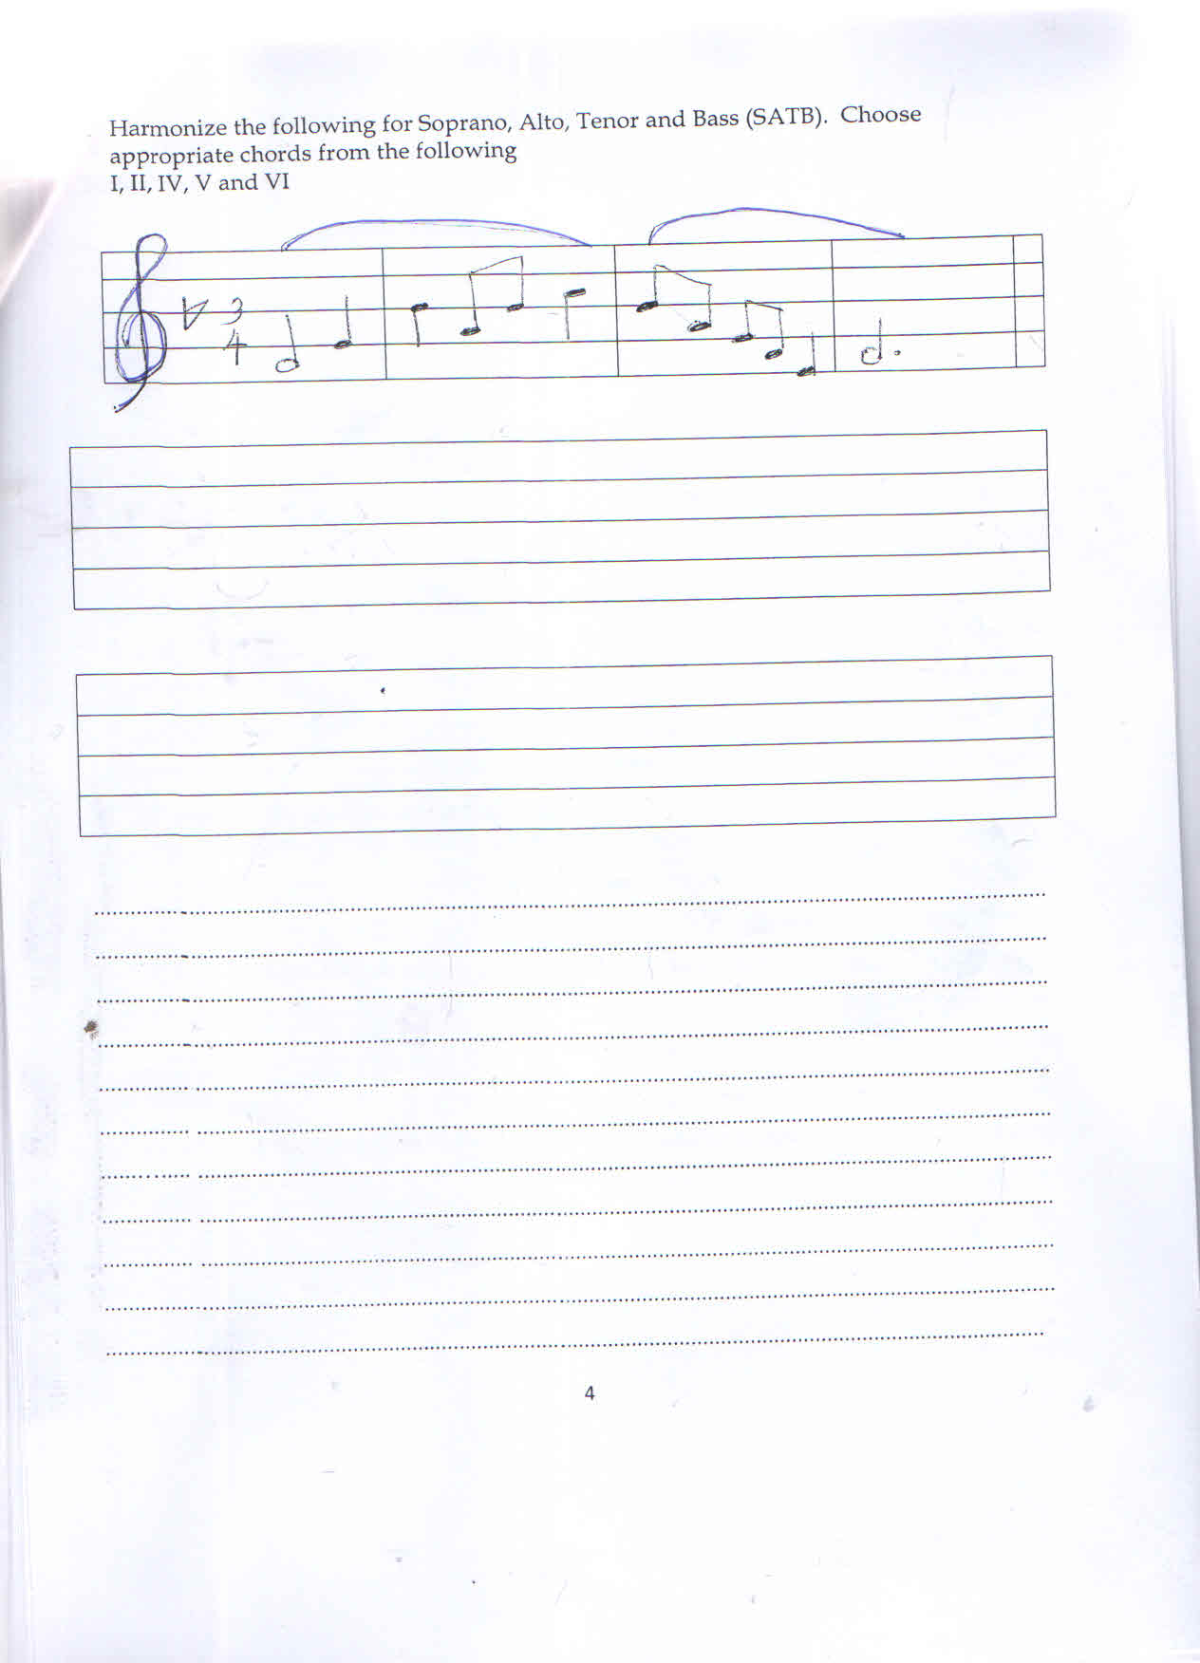

|  |
| --- |
|  |
|  |
|  |
|  |

|  |
| --- |
|  |
|  |
|  |
|  |

................................................................................................................................................................................................................................................................................................................................................................................................................................................................................................................................................................................................................................................................................................................................................................................................................................................................................................................................................................................................….................................................................................................................................................................................................................................................................................................................... ..............................................................................................................................................................................................................................................................................................................................

1. **SECTION B : HISTORY AND ANALYSIS**
2. **i) AFRICAN MUSIC**

State three differences between a lyre and a harp (3 mks)

.......................................................................................................................................................................................................................................................................................................................................................................................................................................................................................................................................................................................................................................................................................................................................................................................................................................................................................................................................................................................................................................................................................................................................................................................................................................................................................................................................................................................................................................................................................

ii) Name two techniques of producing different sounds on an African traditional drum.

(2 mks)

.............................................................................................................................................................................................................................................................................................................................................................................................................................................................................................

1. Morobo is a traditional Kenyan dance.
2. Name the community that performs the dance. (1 mk)

.....................................................................................................................................................................….....................................................................................................................................................

1. Name two occasions during which the dance is performed (2 mks)

............................................................................................................................................................... ..............................................................................................................................................................................................................................................................................................................................

1. Outline four functions of music in African Traditional therapy. (4 mks)

...........................................................................................................................................................................................................................................................................................................................................................................................................................................................................................................................................................................................................................................................................................................................................................................................................................

1. Identify flutes from the list of instruments (2 mks
2. Murenge
3. Ndururet
4. Aregeregeret
5. Ekegogo

...........................................................................................................................................................................................................................................................................................................................................................................................................................................................................................................................................................................................................................................................................................................................................................................................................................

1. **WESTERN MUSIC ANSWER ANY TWO QUESTIONS**
2. **THOMAS TALLIS**
3. Name Thomas Tallis’s nationality (1 mk)

..............................................................................................................................................................................................................................................................................................................................

1. Name some three characteristic features of his Aglican chant. (3 mks)

............................................................................................................................................................................................................................................................................................................................. ..............................................................................................................................................................................................................................................................................................................................

1. Mention two of his works (2 mks)

.............................................................................................................................................................................................................................................................................................................................................................................................................................................................................................

1. Name one of his keyboard works (1 mk)

..............................................................................................................................................................................................................................................................................................................................

1. **GEORGE FREDRIC HANDEL**
2. Name the period of Western history Handel lived (1mk)

..............................................................................................................................................................................................................................................................................................................................

1. Name three of Fredric Handel’s contribution to the music of Baroque period

(3 mks)

............................................................................................................................................................................................................................................................................................................................................................................................................................................................................................................................................................................................................................................................

1. Name two of his appointments (2 mks)

.............................................................................................................................................................................................................................................................................................................................................................................................................................................................................................

1. Name one of his church music (1 mk)

......…....................................................................................................................................................................................................................................................................................................................

1. **CARL PHILIP EMMANUEL BACH**
2. When was he born? (1 mk)

......…....................................................................................................................................................................................................................................................................................................................

1. State three factors that influenced CPE to be a musician (3 mks)

......…....................................................................................................................................................................................................................................................................................................................

......…..................................................................................................................................................... ......….....................................................................................................................................................

1. Name three keyboard sonatas composed by CPE Bach (3 mks)

............................................................................................................................................................... ......…..........................................................................................................................................................................................................................................................................................................................….....................................................................................................................................................

**D. FRANZ SCHUBERT**

i) When was Franz Schubert born? (1 mk)

............................................................................................................................................................... ......….....................................................................................................................................................

ii) Mention four musician who influenced Franz Schubert to be a musician (4 mks)

..............................................................................................................................................................

......…..................................................................................................................................................... ......….................................................................................................................................................................................................................................................................................................................... ......…....................................................................................................................................................................................................................................................................................................................

......….................................................................................................................................................................................................................................................................................................................... ......…....................................................................................................................................................................................................................................................................................................................

......….....................................................................................................................................................

iii) Name two of his works (2 mks)

......…..........................................................................................................................................................................................................................................................................................................................….....................................................................................................................................................

1. **PRESCRIBED AFRICA ANALYSIS (10 MKS)**

**A KIPSIGIS PLANTING AND HARVEST SONG BY TENWEK PRIMARY SCHOOL (KMF)(10 MKS)**

1. i) Explain three ways in which variation has been achieved in the recording.

(3 mks)

...............................................................................................................................................................

...............................................................................................................................................................

......…....................................................................................................................................................................................................................................................................................................................

1. i) Name the main accompanying instrument used in the recording (1 mk)

...............................................................................................................................................................

......….....................................................................................................................................................

1. Explain how climax has been achieved in the recording (3 mks)

...............................................................................................................................................................

............................................................................................................................................................... ......…....................................................................................................................................................................................................................................................................................................................

......…....................................................................................................................................................................................................................................................................................................................

1. **ANALYSIS OF PRESCRIBED WESTERN MUSIC**

**(O REST IN THE LORD) ARIA FROM ELIJAH BY FELIX MENDELSSONHN**

1. Name composition techniques that have been used in bars (3 mks)
2. 1 and 19: …………………………………………………………………………..
3. Bar one: ……………………………………………………………………………..
4. 16 and 17: …………………………………………………………………………..
5. What is the media of this work? (1 mk)

......…....................................................................................................................................................................................................................................................................................................................

1. Give three roles played by the instrument in this work. (3 mks)

......…..................................................................................................................................................... ......…....................................................................................................................................................................................................................................................................................................................

......….....................................................................................................................................................

1. What is the dynamic range of this piece (1 mk)

...............................................................................................................................................................

...............................................................................................................................................................

1. Name articulation marks used in this work (2mks)

......…....................................................................................................................................................................................................................................................................................................................

1. **UNPREPARED ANALYSIS**

***Refer to the music below and answer questions that follow.***

***Allegro moderato 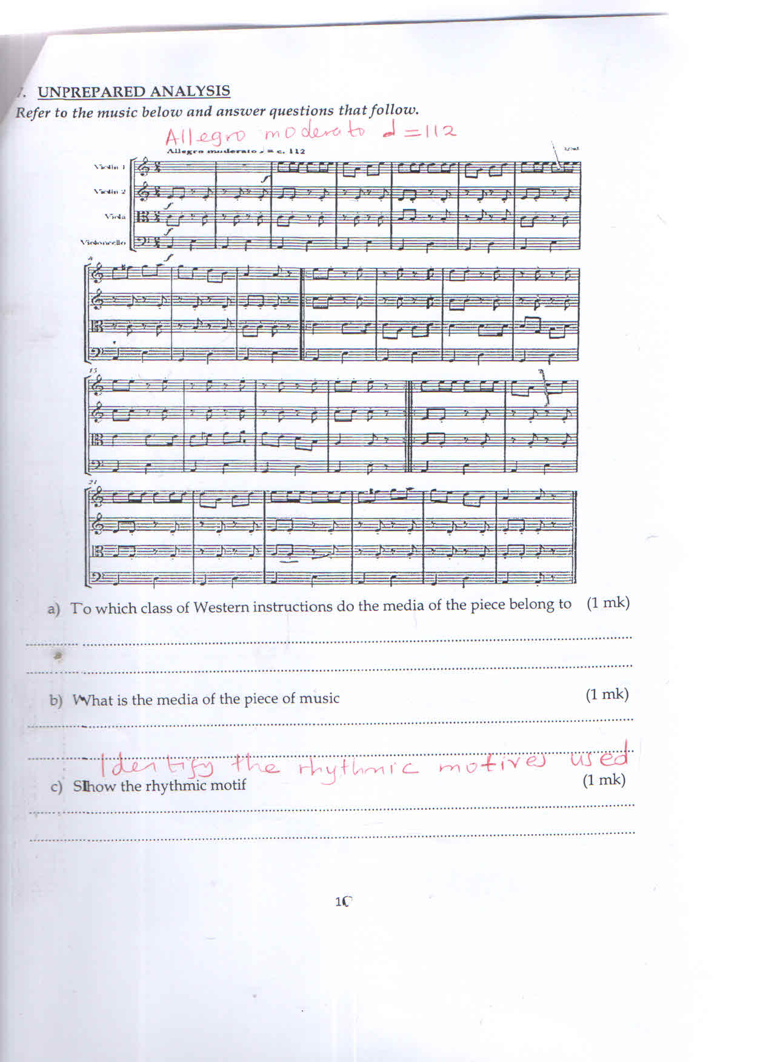 = 112***

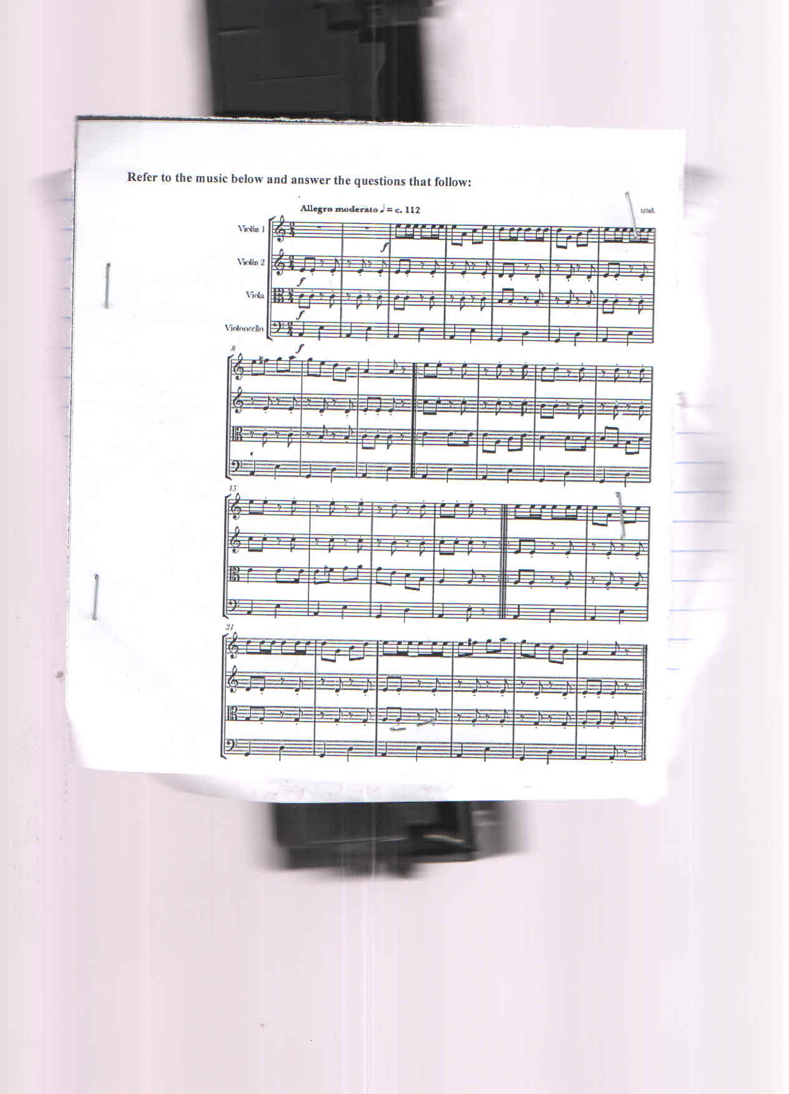

1. To which class of Western orchestra do the media of the piece belong to (1 mk)

............................................................................................................................................................... ......….....................................................................................................................................................

1. What is the media of the piece of music (1 mk)

...............................................................................................................................................................

......….....................................................................................................................................................

1. Identify the rhythmic motives used. (1 mk)

......…..................................................................................................................................................................................................................................................................................................................

1. Rewrite bar one Viola on treble clef (3 mks)

|  |
| --- |
|  |
|  |
|  |
|  |

1. **SECTION C : GENERAL MUSIC KNOWLEDGE**
2. Transpose the following melody a major 2nd down (4 mks)

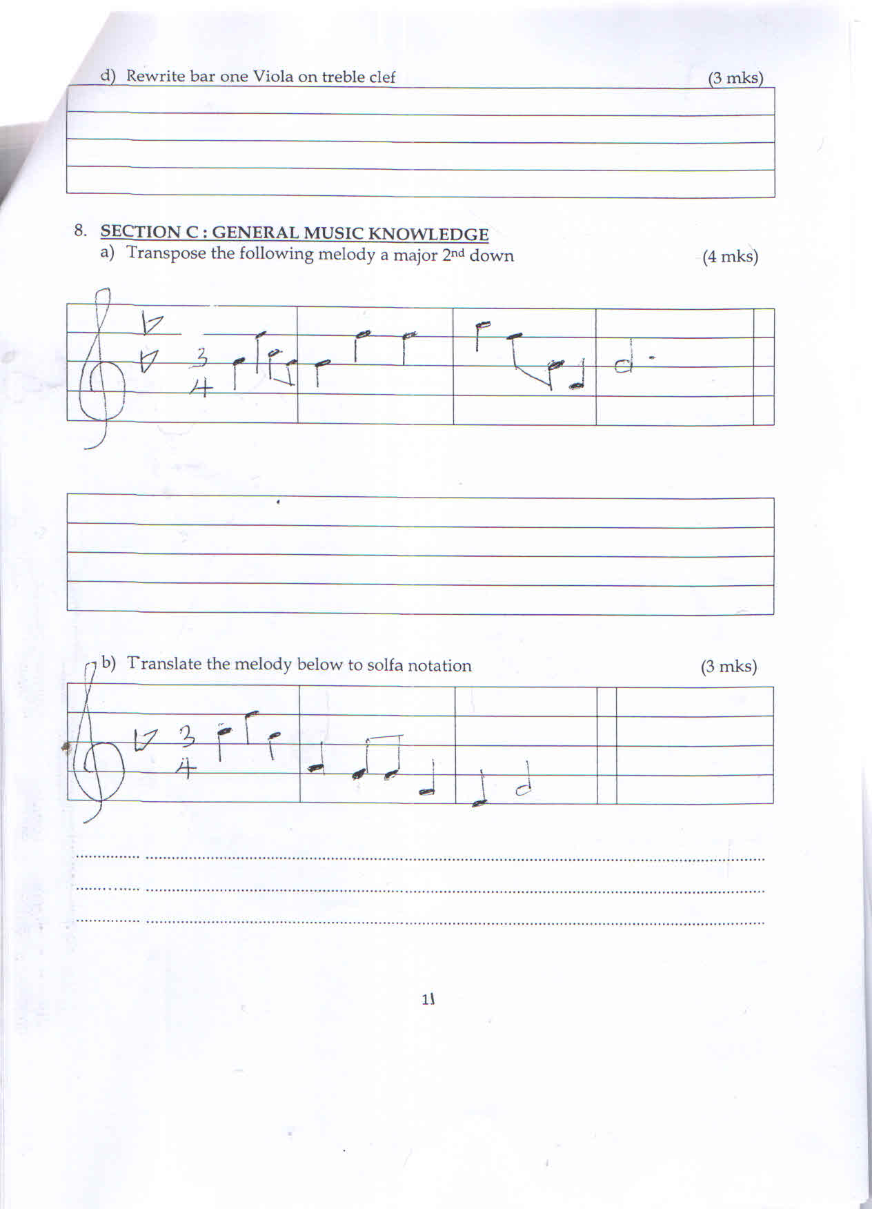

c) How are the following ornaments played

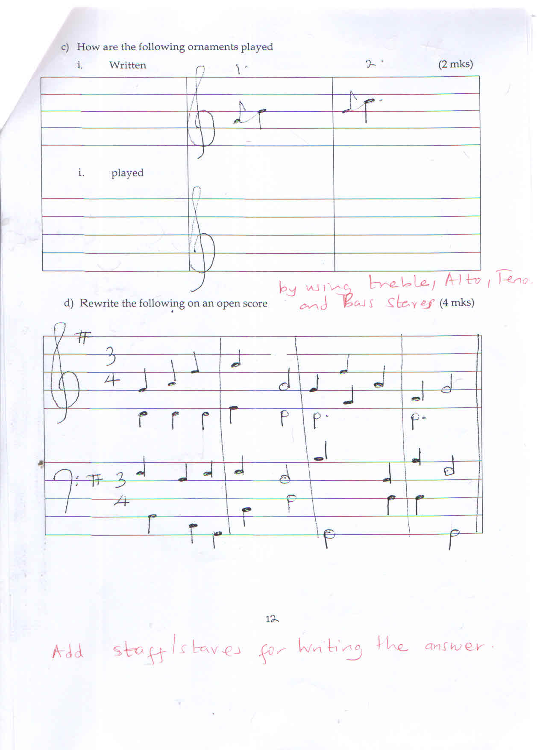

d) Rewrite the following on an open score by using treble, Alto, Tenor and Bass stares

(4 mks)



|  |
| --- |
|  |
|  |
|  |
|  |

|  |
| --- |
|  |
|  |
|  |
|  |

|  |
| --- |
|  |
|  |
|  |
|  |

|  |
| --- |
|  |
|  |
|  |
|  |

1. Explain the meaning of the following terms as used in music (2 mks)
2. Maestoso

......…....................................................................................................................................................................................................................................................................................................................

1. Poco a poco

......…....................................................................................................................................................................................................................................................................................................................

1. State and explain the role of costumes and décor in African traditional dances

(1 mk)

......….....................................................................................................................................................